Superpower: Bearhug! The famous Teddybear Workshop of IMWe 2018
Want to make your very own cuddly teddybear? Here are some good links to good patterns you can start with (sorted from simple to complicated)! Below the patterns you will also find a list of some useful books and links.
“Print and sew bear”:
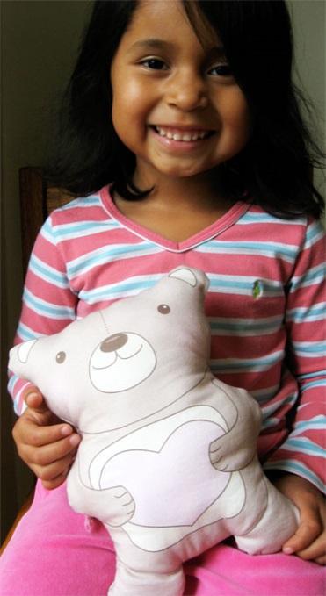
https://www.skiptomylou.org/simple-sewing-project-for-kids-free-printable-bear/

The workshop quick favourite “Warren, the Charity Bear”:
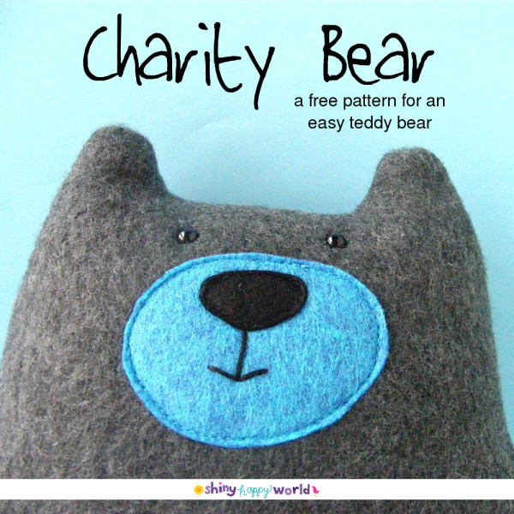
https://www.shinyhappyworld.com/2014/04/warren-charity-bear-free-teddy-bear-pattern.html
Folk Art Mohair Teddy Bear:
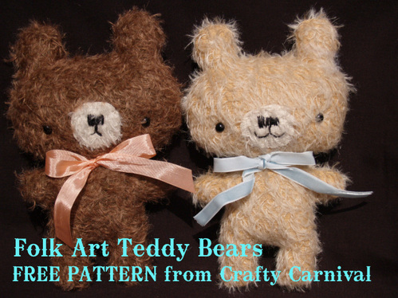
http://missyballance.typepad.com/crafty_carnival/files/folk_art_teddy_bear.pdf

Baby shower flat teddy:
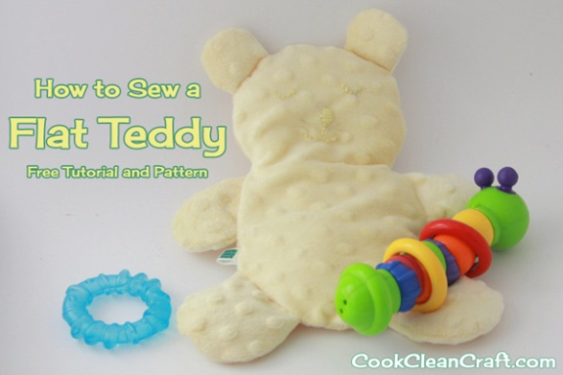
http://cookcleancraft.com/2013/05/baby-shower-gift-flat-teddy-tutorial/

Simple Bear /Little Ted:
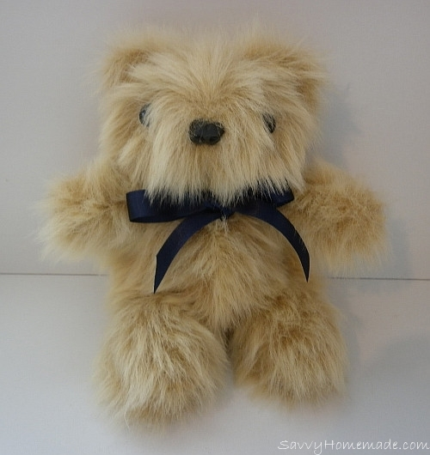
https://www.savvyhomemade.com/make-your-own-teddy-bear/
and
https://www.savvyhomemade.com/make-your-own-teddy-bear/

Pumpkin Teddy
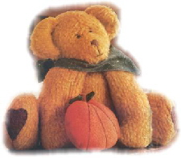

http://www.sewing.org/html/sew_beary_teddy.html

Huge and oh-so-cuddly Howjoyful bear (the “Panda” of the workshop):
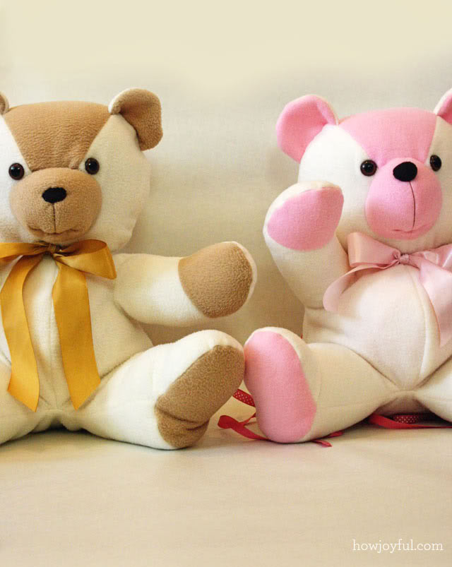
https://www.howjoyful.com/2010/05/howjoyful-bear-tutorial-and-pattern/
and
https://www.dropbox.com/s/2yh6q68gzwmsfph/HowJoyfulBear.pdf?dl=0
Traditional Teddy Bear:
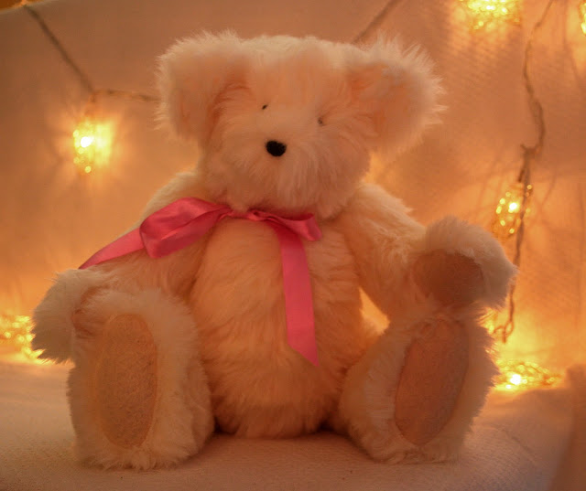
http://thebutterflybalcony.blogspot.de/2009/12/things-to-make-do-make-yourself.html

Baby Pip, a small fully jointed bear:

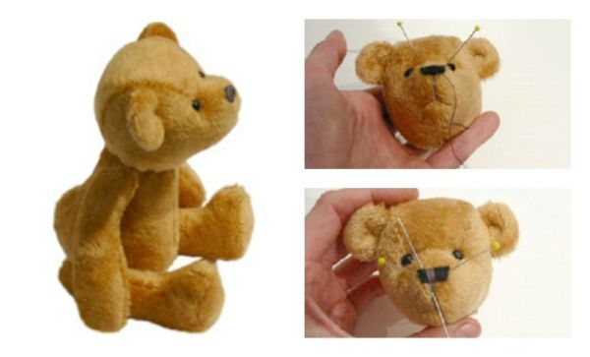
https://craftbits.com/project/baby-pip-teddy-bear/

Bonjour:
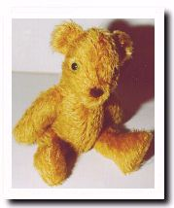
http://www.teddybearsearch.com/patterns/patpart.mv

Some teddymaking books
The Encyclopedia of Teddy-Bear Making techniques (DE: Mein Heiss Geliebter Teddybär, FI: Nalleverstas) by Alicia Merrett & Anne Stephens
  - If I had to choose one Teddy book, it would be this one!
  - Very comprehensive with plenty and lots of photos of all work steps. Also a few patterns.
  - Comprehensive guide on how to draw your very own teddy pattern!
Teddybären selber nähen by Monika Schleich
  - Many patterns and basic info
Making Teddy Bears by Joyce Luckin
  - Many different teddy bear patterns with names
  - https://books.google.de/books?id=V-JUta_4VmkC&printsec=frontcover&hl=fi#v=onepage&q&f=false
Teddybären selber Machen by Helga Schepp
  - A mix-and-match pattern collection for making over 700 000 different bears!
Das grosse Singer Nähbuch Stofftiere by Rabea Rauer & Yvonne Reidelbach
  - Actually meant for machine sewing, and mostly other soft toys than teddybears, but with some nice patterns nevertheless.

Random Useful Links
- http://www.teddybearacademy.net/category/bear-making-tips/
  - Seems to be full of all kinds of handy hints and lists
- http://soggibottom.blogspot.de/2009/11/free-1925-soggibottom-teddy-bear_30.html
  - About joints
- https://www.thespruce.com/sew-a-teddy-bear-pattern-2978397
  - Here’s where I first got some ideas on teddy bear pattern types. Please note that the pictures on the page have often nothing to do with the bear pattern they are linked to!
- https://www.smithsonianmag.com/history/the-history-of-the-teddy-bear-from-wet-and-angry-to-soft-and-cuddly-170275899/
  - Teddy history from Smithsonian
- https://en.wikipedia.org/wiki/Teddy_bear
  - Teddy trivia from Wikipedia
- http://www.oxfordteddybearuniversity.co.uk/Bear_History.php
  - Teddy history
- http://www.mibepa.info/tb/tb000.htm
  - Teddy info

Shops & products:
http://www.probaer.de/
http://www.baerenstuebchen.de/shop/index.php
http://www.baerenlaedle.de/index.php
https://shop.bastelmaus-shop.de/index.php
https://www.amazon.de/264-tlg-6-12mm-Teddyaugen-Sicherheitsaugen-Kunststoffaugen/dp/B018YVOAUM/ref=pd_sim_21_5?_encoding=UTF8&psc=1&refRID=SS8W8Z3MZSC3855SYXGR
https://www.amazon.de/Spielzeug-Sicherheit-Teddyb%C3%A4r-Kunststoff-Unterlegscheiben/dp/B0747PPFQB/ref=pd_sim_201_3?_encoding=UTF8&psc=1&refRID=WQZ5MVMWPGSMRQ3WJ61Z

